Classic Models Sales Analysis & Report

(SQL Queries)

1. **Sales trend by customers credit limit.**

SELECT creditLimit AS 'Credit Limit', SUM(totalPrice) AS 'Total Purchase',

COUNT(distinct o.orderNumber) AS 'Num of Order' FROM orders o JOIN customers c

ON o.customerNumber = c.customerNumber

JOIN orderdetails od ON o.orderNumber = od.orderNumber

GROUP BY 1

ORDER BY 2 DESC;

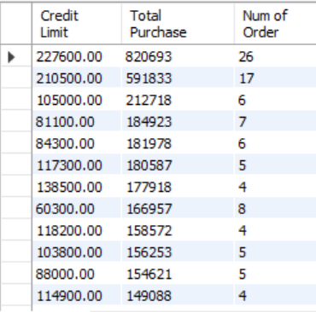

1. **Top 5 Sales Employee Name based on Sales**

SELECT e.firstName, e.lastName, e.jobTitle, SUM(totalPrice) AS 'total_sales_$'

FROM customers c JOIN employees e ON c.salesRepEmployeeNumber =

e.employeeNumber

JOIN orders o ON c.customerNumber = o.customerNumber

JOIN orderdetails od ON o.orderNumber = od.orderNumber

GROUP BY e.firstName, e.lastName, e.jobTitle

ORDER BY total_sales_$ DESC LIMIT 5;

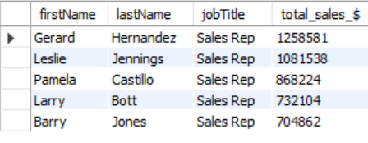

1. **Profit % by product category.**

SELECT pl.productline AS 'Product_Cat', (SUM(profit) / SUM(totalPrice)) * 100 AS 'Profit_%' FROM orderdetails od

JOIN products p ON od.productCode = p.productCode

JOIN productlines pl ON p.productLine = pl.productLine

GROUP BY 1

ORDER BY 2;

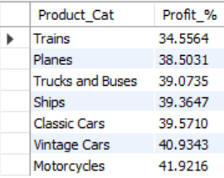

1. **Sales by offices**

SELECT off.city, off.country, SUM(totalPrice) AS 'total_sale' FROM offices off JOIN employees e

ON off.officeCode = e.officeCode

JOIN customers c on e.employeeNumber = c.salesRepEmployeeNumber

JOIN orders o ON c.customerNumber = o.customerNumber

JOIN orderdetails od ON o.orderNumber = od.orderNumber

GROUP BY city, country;

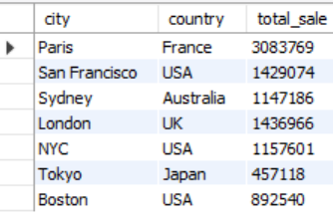

1. **Product quantity in stock (Category wise).**

select productLine, sum(quantityInStock) quantity_instock from products

group by productLine;

